**ARYAMAN MISHRA**

**19BCE1027**

Part A:

## You are given 9 one-line documents here. Consider the following keywords to represent the documents in the vector space model:

## [1] Automotive [2] Car [3] motorcycles [4] self-drive [5] IoT [6] hire [7] Dhoni

Represent the documents in vector space Model using these keywords and use it as input to cluster the documents using Manhattan distance as parameter. Ignore case differences.

You need to do hierarchical clustering with single-link, complete-link, average-link agglomerative clustering.

**Documents for use in question**

**Doc1**

**Electric automotive maker Tesla Inc. is likely to introduce its products in India sometime in the summer of 2017.**

**Doc 2**

**Automotive major Mahindra likely to introduce driverless cars**

**Doc 3**

**BMW plans to introduce its own motorcycles in india**

**Doc 4**

**Just drive, a self-drive car rental firm uses smart vehicle technology based on IoT**

**Doc 5**

**Automotive industry going to hire thousands in 2018**

**Doc 6**

**Famous cricket player Dhoni brought his priced car Hummer which is an SUV**

**Doc 7**

**Dhoni led india to its second world cup victory**

**Doc 8**

**IoT in cars will lead to more safety and make driverless vehicle revolution possible**

**Doc 9**

**Sachin recommended Dhoni for the indian skipper post**

**Data Structure Proposed: Dictionaries.**

**ALGORITHM:**

* **Step-1:**  
  Consider each alphabet as a single cluster and calculate the distance of one cluster from all the other clusters.
* **Step-2:**  
  In the second step comparable clusters are merged together to form a single cluster. Let’s say cluster (B) and cluster (C) are very similar to each other therefore we merge them in the second step similarly with cluster (D) and (E) and at last, we get the clusters  
  [(A), (BC), (DE), (F)]
* **Step-3:**  
  We recalculate the proximity according to the algorithm and merge the two nearest clusters([(DE), (F)]) together to form new clusters as [(A), (BC), (DEF)]
* **Step-4:**  
  Repeating the same process; The clusters DEF and BC are comparable and merged together to form a new cluster. We’re now left with clusters [(A), (BCDEF)].
* **Step-5:**  
  At last the two remaining clusters are merged together to form a single cluster [(ABCDEF)].

**IMPLEMENTATION CODE AND RESULTS:**

single-link

# Importing the libraries  
import string  
import pandas as pd  
import math  
import matplotlib.pyplot as plt  
  
  
class document_clustering(object):  
  
 def __init__(self, file_dict, word_list):  
 self.file_dict = file_dict  
 self.word_list = word_list  
  
 def tokenize_document(self, document):  
 *"""Returns a list of words contained in the document after converting  
 it to lowercase and striping punctuation marks"""* terms = document.lower().split()  
 return [term.strip(string.punctuation) for term in terms]  
  
 def create_word_listing(self):  
 *"""Function to create the word listing of the objects"""* # Dictionary to hold the frequency of words in word_list with file_index as key  
 self.listing_dict_ = {}  
  
 for id in self.file_dict:  
 temp_word_list = []  
 f = open(self.file_dict[id], 'r')  
 document = f.read()  
 terms = self.tokenize_document(document)  
 for term in self.word_list:  
 temp_word_list.append(terms.count(term.lower()))  
 self.listing_dict_[id] = temp_word_list  
  
 print('Word listing of each document')  
 for id in self.listing_dict_:  
 print('%d: %s' % (id, self.listing_dict_[id]))  
  
 def create_document_matrix(self):  
 *"""Function to create the document distance matrix"""* self.labels_ = ['doc%d' % (id) for id in self.file_dict]  
 main_list = []  
 for id1 in self.file_dict:  
 temp_list = []  
 for id2 in self.file_dict:  
 dist = 0  
 for term1, term2 in zip(self.listing_dict_[id1], self.listing_dict_[id2]):  
 dist += abs(term1 - term2)  
 temp_list.append(round(math.sqrt(dist), 4))  
 main_list.append(temp_list)  
  
 self.distance_matrix_ = pd.DataFrame(main_list, index=self.labels_, columns=self.labels_)  
 print('\nDistance Matrix')  
 print(self.distance_matrix_)  
  
 def cluster(self):  
 *"""Create the vector space model from the documents. Perform Hierarchical  
 Clustering"""* from scipy.cluster.hierarchy import linkage  
 row_cluster = linkage(self.distance_matrix_.values,  
 method='single',  
 metric='cityblock')  
 from scipy.cluster.hierarchy import dendrogram  
 dn = dendrogram(row_cluster, labels=self.labels_)  
 plt.ylabel('Manhattan Distance')  
 plt.xticks(rotation=90)  
 plt.savefig('dendrogram1.png', dpi=300)  
 plt.show()  
  
  
# Dictionary containing the file_index and path  
file_dict = {1:r"C:\Users\aryam\Desktop\Fall Sem 2021\Web Mining Lab\Lab 7 23-9-21\doc1.txt",  
 2:r"C:\Users\aryam\Desktop\Fall Sem 2021\Web Mining Lab\Lab 7 23-9-21\doc2.txt",  
 3:r"C:\Users\aryam\Desktop\Fall Sem 2021\Web Mining Lab\Lab 7 23-9-21\doc3.txt",  
 4:r"C:\Users\aryam\Desktop\Fall Sem 2021\Web Mining Lab\Lab 7 23-9-21\doc4.txt",  
 5:r"C:\Users\aryam\Desktop\Fall Sem 2021\Web Mining Lab\Lab 7 23-9-21\doc5.txt",  
 6:r"C:\Users\aryam\Desktop\Fall Sem 2021\Web Mining Lab\Lab 7 23-9-21\doc6.txt",  
 7:r"C:\Users\aryam\Desktop\Fall Sem 2021\Web Mining Lab\Lab 7 23-9-21\doc7.txt",  
 8:r"C:\Users\aryam\Desktop\Fall Sem 2021\Web Mining Lab\Lab 7 23-9-21\doc8.txt",  
 9:r"C:\Users\aryam\Desktop\Fall Sem 2021\Web Mining Lab\Lab 7 23-9-21\doc9.txt"}  
# List containing the words using which the vector space model is to be created  
word_list = ['Automotive', 'Car', 'motorcycles', 'self-drive', 'IoT', 'hire', 'Dhoni']  
  
# Creating class instance and calling appropriate functions  
document_cluster = document_clustering(file_dict=file_dict, word_list=word_list)  
document_cluster.create_word_listing()  
document_cluster.create_document_matrix()  
document_cluster.cluster()

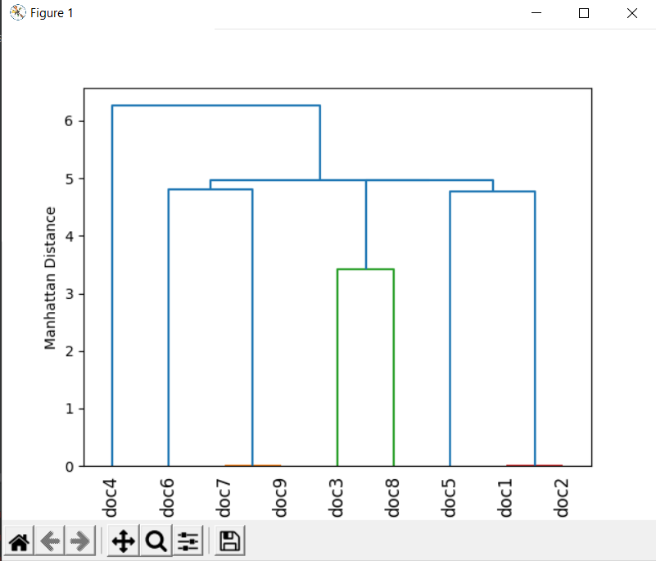

complete-link

# Importing the libraries  
import string  
import pandas as pd  
import math  
import matplotlib.pyplot as plt  
  
  
class document_clustering(object):  
  
 def __init__(self, file_dict, word_list):  
 self.file_dict = file_dict  
 self.word_list = word_list  
  
 def tokenize_document(self, document):  
 *"""Returns a list of words contained in the document after converting  
 it to lowercase and striping punctuation marks"""* terms = document.lower().split()  
 return [term.strip(string.punctuation) for term in terms]  
  
 def create_word_listing(self):  
 *"""Function to create the word listing of the objects"""* # Dictionary to hold the frequency of words in word_list with file_index as key  
 self.listing_dict_ = {}  
  
 for id in self.file_dict:  
 temp_word_list = []  
 f = open(self.file_dict[id], 'r')  
 document = f.read()  
 terms = self.tokenize_document(document)  
 for term in self.word_list:  
 temp_word_list.append(terms.count(term.lower()))  
 self.listing_dict_[id] = temp_word_list  
  
 print('Word listing of each document')  
 for id in self.listing_dict_:  
 print('%d: %s' % (id, self.listing_dict_[id]))  
  
 def create_document_matrix(self):  
 *"""Function to create the document distance matrix"""* self.labels_ = ['doc%d' % (id) for id in self.file_dict]  
 main_list = []  
 for id1 in self.file_dict:  
 temp_list = []  
 for id2 in self.file_dict:  
 dist = 0  
 for term1, term2 in zip(self.listing_dict_[id1], self.listing_dict_[id2]):  
 dist += abs(term1 - term2)  
 temp_list.append(round(math.sqrt(dist), 4))  
 main_list.append(temp_list)  
  
 self.distance_matrix_ = pd.DataFrame(main_list, index=self.labels_, columns=self.labels_)  
 print('\nDistance Matrix')  
 print(self.distance_matrix_)  
  
 def cluster(self):  
 *"""Create the vector space model from the documents. Perform Hierarchical  
 Clustering"""* from scipy.cluster.hierarchy import linkage  
 row_cluster = linkage(self.distance_matrix_.values,  
 method='complete',  
 metric='cityblock')  
 from scipy.cluster.hierarchy import dendrogram  
 dn = dendrogram(row_cluster, labels=self.labels_)  
 plt.ylabel('Manhattan Distance')  
 plt.xticks(rotation=90)  
 plt.savefig('dendrogram1.png', dpi=300)  
 plt.show()  
  
  
# Dictionary containing the file_index and path  
file_dict = {1:r"C:\Users\aryam\Desktop\Fall Sem 2021\Web Mining Lab\Lab 7 23-9-21\doc1.txt",  
 2:r"C:\Users\aryam\Desktop\Fall Sem 2021\Web Mining Lab\Lab 7 23-9-21\doc2.txt",  
 3:r"C:\Users\aryam\Desktop\Fall Sem 2021\Web Mining Lab\Lab 7 23-9-21\doc3.txt",  
 4:r"C:\Users\aryam\Desktop\Fall Sem 2021\Web Mining Lab\Lab 7 23-9-21\doc4.txt",  
 5:r"C:\Users\aryam\Desktop\Fall Sem 2021\Web Mining Lab\Lab 7 23-9-21\doc5.txt",  
 6:r"C:\Users\aryam\Desktop\Fall Sem 2021\Web Mining Lab\Lab 7 23-9-21\doc6.txt",  
 7:r"C:\Users\aryam\Desktop\Fall Sem 2021\Web Mining Lab\Lab 7 23-9-21\doc7.txt",  
 8:r"C:\Users\aryam\Desktop\Fall Sem 2021\Web Mining Lab\Lab 7 23-9-21\doc8.txt",  
 9:r"C:\Users\aryam\Desktop\Fall Sem 2021\Web Mining Lab\Lab 7 23-9-21\doc9.txt"}  
# List containing the words using which the vector space model is to be created  
word_list = ['Automotive', 'Car', 'motorcycles', 'self-drive', 'IoT', 'hire', 'Dhoni']  
  
# Creating class instance and calling appropriate functions  
document_cluster = document_clustering(file_dict=file_dict, word_list=word_list)  
document_cluster.create_word_listing()  
document_cluster.create_document_matrix()  
document_cluster.cluster()

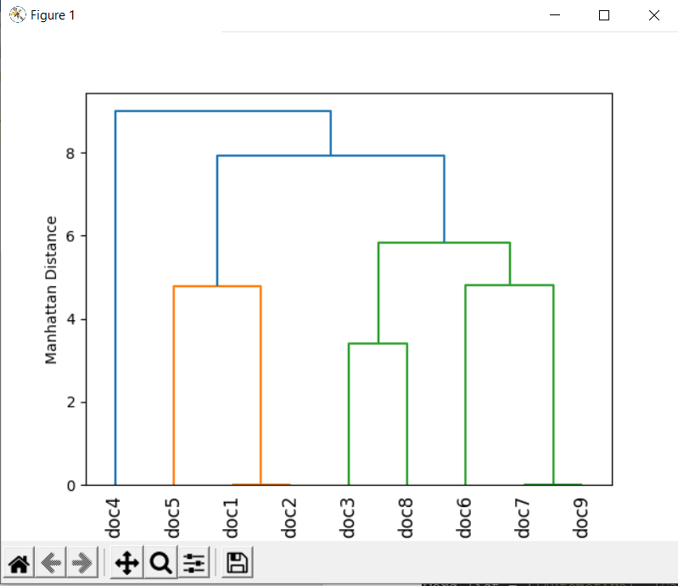

average-link

# Importing the libraries  
import string  
import pandas as pd  
import math  
import matplotlib.pyplot as plt  
  
  
class document_clustering(object):  
  
 def __init__(self, file_dict, word_list):  
 self.file_dict = file_dict  
 self.word_list = word_list  
  
 def tokenize_document(self, document):  
 *"""Returns a list of words contained in the document after converting  
 it to lowercase and striping punctuation marks"""* terms = document.lower().split()  
 return [term.strip(string.punctuation) for term in terms]  
  
 def create_word_listing(self):  
 *"""Function to create the word listing of the objects"""* # Dictionary to hold the frequency of words in word_list with file_index as key  
 self.listing_dict_ = {}  
  
 for id in self.file_dict:  
 temp_word_list = []  
 f = open(self.file_dict[id], 'r')  
 document = f.read()  
 terms = self.tokenize_document(document)  
 for term in self.word_list:  
 temp_word_list.append(terms.count(term.lower()))  
 self.listing_dict_[id] = temp_word_list  
  
 print('Word listing of each document')  
 for id in self.listing_dict_:  
 print('%d: %s' % (id, self.listing_dict_[id]))  
  
 def create_document_matrix(self):  
 *"""Function to create the document distance matrix"""* self.labels_ = ['doc%d' % (id) for id in self.file_dict]  
 main_list = []  
 for id1 in self.file_dict:  
 temp_list = []  
 for id2 in self.file_dict:  
 dist = 0  
 for term1, term2 in zip(self.listing_dict_[id1], self.listing_dict_[id2]):  
 dist += abs(term1 - term2)  
 temp_list.append(round(math.sqrt(dist), 4))  
 main_list.append(temp_list)  
  
 self.distance_matrix_ = pd.DataFrame(main_list, index=self.labels_, columns=self.labels_)  
 print('\nDistance Matrix')  
 print(self.distance_matrix_)  
  
 def cluster(self):  
 *"""Create the vector space model from the documents. Perform Hierarchical  
 Clustering"""* from scipy.cluster.hierarchy import linkage  
 row_cluster = linkage(self.distance_matrix_.values,  
 method='average',  
 metric='cityblock')  
 from scipy.cluster.hierarchy import dendrogram  
 dn = dendrogram(row_cluster, labels=self.labels_)  
 plt.ylabel('Manhattan Distance')  
 plt.xticks(rotation=90)  
 plt.savefig('dendrogram1.png', dpi=300)  
 plt.show()  
  
  
# Dictionary containing the file_index and path  
file_dict = {1:r"C:\Users\aryam\Desktop\Fall Sem 2021\Web Mining Lab\Lab 7 23-9-21\doc1.txt",  
 2:r"C:\Users\aryam\Desktop\Fall Sem 2021\Web Mining Lab\Lab 7 23-9-21\doc2.txt",  
 3:r"C:\Users\aryam\Desktop\Fall Sem 2021\Web Mining Lab\Lab 7 23-9-21\doc3.txt",  
 4:r"C:\Users\aryam\Desktop\Fall Sem 2021\Web Mining Lab\Lab 7 23-9-21\doc4.txt",  
 5:r"C:\Users\aryam\Desktop\Fall Sem 2021\Web Mining Lab\Lab 7 23-9-21\doc5.txt",  
 6:r"C:\Users\aryam\Desktop\Fall Sem 2021\Web Mining Lab\Lab 7 23-9-21\doc6.txt",  
 7:r"C:\Users\aryam\Desktop\Fall Sem 2021\Web Mining Lab\Lab 7 23-9-21\doc7.txt",  
 8:r"C:\Users\aryam\Desktop\Fall Sem 2021\Web Mining Lab\Lab 7 23-9-21\doc8.txt",  
 9:r"C:\Users\aryam\Desktop\Fall Sem 2021\Web Mining Lab\Lab 7 23-9-21\doc9.txt"}  
# List containing the words using which the vector space model is to be created  
word_list = ['Automotive', 'Car', 'motorcycles', 'self-drive', 'IoT', 'hire', 'Dhoni']  
  
# Creating class instance and calling appropriate functions  
document_cluster = document_clustering(file_dict=file_dict, word_list=word_list)  
document_cluster.create_word_listing()  
document_cluster.create_document_matrix()  
document_cluster.cluster()

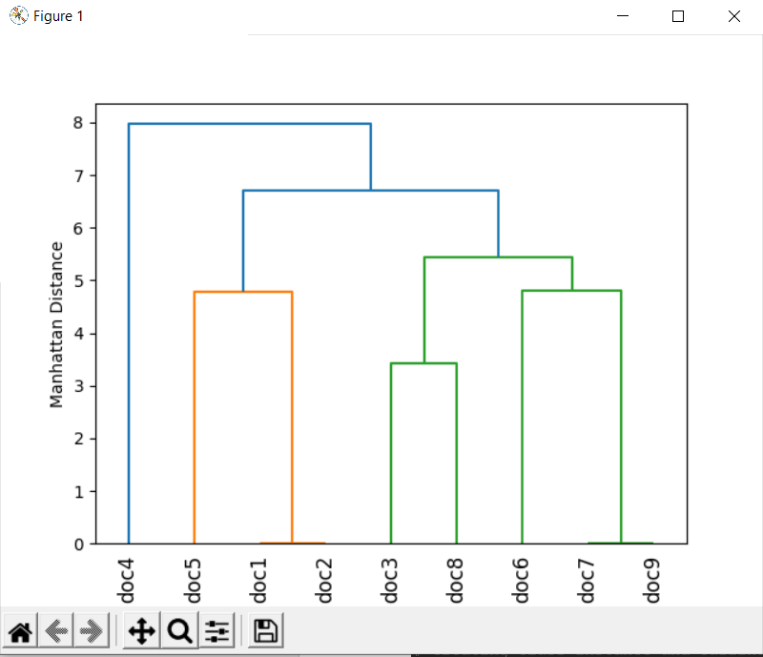

Part B

Use the same program which you have developed for part A to do “hierarchical clustering” of the following web documents. Use the keywords.

[1] Tesla [2] Electric [3] Car/Vehicle/Automobile [4] pollution [5] de-monetisation [6] GST [7] black money

Download the webpage into a .txt file [ignore images, tables and limit the size of the document to 500 words Max] and build your vector space model using Term frequency.

Ignore case differences. Treat singular and plural of nouns as same. Treat Car/vehicle/automobile as one word [synonyms]. Treat “black money” as a single word.

List of webpages:

[1] <https://www.zigwheels.com/newcars/Tesla>

[2] <https://www.financialexpress.com/auto/car-news/mahindra-to-launch-indias-first-electric-suv-in-2019-all-new-e-verito-sedan-on-cards/1266853/>

[3] <https://en.wikipedia.org/wiki/Toyota_Prius>

[4] <https://economictimes.indiatimes.com/industry/auto/auto-news/government-plans-new-policy-to-promote-electric-vehicles/articleshow/65237123.cms>

[5] <https://indianexpress.com/article/india/india-news-india/demonetisation-hits-electric-vehicles-industry-society-of-manufacturers-of-electric-vehicles-4395104/>

[6] <https://www.livemint.com/Politics/ySbMKTIC4MINsz1btccBJO/How-demonetisation-affected-the-Indian-economy-in-10-charts.html>

[7] <https://www.hrblock.in/blog/impact-gst-automobile-industry-2/>

[8] <https://inc42.com/buzz/electric-vehicles-this-week-centre-reduces-gst-on-lithium-ion-batteries-hyundai-to-launch-electric-suv-in-india-and-more/>

[9] <https://www.youthkiawaaz.com/2017/12/impact-of-demonetisation-on-the-indian-economy/>

[10] <https://indianexpress.com/article/india/demonetisation-effects-cash-crisis-mobile-wallets-internet-banking-4406005/>

[11] <https://www.news18.com/news/business/how-gst-will-curb-tax-evasion-1446035.html>

[12] <https://economictimes.indiatimes.com/small-biz/policy-trends/is-gst-helping-the-indian-economy-for-the-better/articleshow/65319874.cms>

**Data Structure Proposed: Dictionaries.**

**ALGORITHM:**

* **Step-1:**  
  Consider each alphabet as a single cluster and calculate the distance of one cluster from all the other clusters.
* **Step-2:**  
  In the second step comparable clusters are merged together to form a single cluster. Let’s say cluster (B) and cluster (C) are very similar to each other therefore we merge them in the second step similarly with cluster (D) and (E) and at last, we get the clusters  
  [(A), (BC), (DE), (F)]
* **Step-3:**  
  We recalculate the proximity according to the algorithm and merge the two nearest clusters([(DE), (F)]) together to form new clusters as [(A), (BC), (DEF)]
* **Step-4:**  
  Repeating the same process; The clusters DEF and BC are comparable and merged together to form a new cluster. We’re now left with clusters [(A), (BCDEF)].
* **Step-5:**  
  At last the two remaining clusters are merged together to form a single cluster [(ABCDEF)].

**IMPLEMENTATION CODE AND RESULTS:**

import string

import pandas as pd

import math

import matplotlib.pyplot as plt

import requests

import re

from bs4 import BeautifulSoup

from bs4.element import Comment

from nltk.stem import PorterStemmer

# Function to filter the HTML tags and text

def visible_text(element):

    if element.parent.name in ['style', 'title', 'script', 'head', '[document]', 'class', 'a', 'li']:

        return False

    elif isinstance(element, Comment):

        return False

    elif re.match(r"[\s\r\n]+",str(element)):

        return False

    elif re.match(r"www.", str(element)):

        return False

    return True

class document_clustering(object):

    """Implementing the document clustering class.

    It creates the vector space model of the passed documents and then

    creates a Hierarchical Cluster to organize them.

    Parameters:

    -------------

    file_dict: dictionary

        Contains the path of the different files to be read.

        Format: {file_index: path}

    word_list: list

        Contains the list of words using which the vector space model is to be

        created.

    Attributes:

    -----------

    listing_dict_: dictionary

        Contains the frequency of the words in each document as file_index as key

        and frequency list as value.

    distance_matrix_ : pandas-dataframe

        Contains the sqaure matrix of documents containing the pairwise distance between them

    labels_: list

        Contains the labels for document names

    """

    def __init__(self, file_dict, word_list):

        self.file_dict = file_dict

        self.word_list = word_list

    def tokenize_document(self, document):

        """Returns a list of words contained in the document after converting

        it to lowercase and striping punctuation marks"""

        ps = PorterStemmer()

        terms = []

        for i in document:

            temp = i.lower().replace('vehicle', 'car').replace('automobile', 'car').split()

            for j in temp:

                terms.append(j)

        return [ps.stem(term.strip(string.punctuation)) for term in terms]

    def create_word_listing(self):

        """Function to create the word listing of the objects"""

        # Dictionary to hold the frequency of words in word_list with file_index as key

        self.listing_dict_ = {}

        for id in self.file_dict:

            temp_word_list = []

            response = requests.get(self.file_dict[id])

            soup = BeautifulSoup(response.text, 'html.parser')

            text = soup.find_all(text = True)

            text = list(filter(visible_text, text))

            terms = self.tokenize_document(text)

            for term in self.word_list[:500]:

                temp_word_list.append(terms.count(term.lower()))

            self.listing_dict_[id] = temp_word_list

        print('Word listing of each document')

        for id in self.listing_dict_:

            print('%d:  %s' % (id, self.listing_dict_[id]))

    def create_document_matrix(self):

        """Function to create the document distance matrix"""

        self.labels_ = ['web%d' % (id) for id in self.file_dict]

        main_list = []

        for id1 in self.file_dict:

            temp_list = []

            for id2 in self.file_dict:

                dist = 0

                for term1, term2 in zip(self.listing_dict_[id1], self.listing_dict_[id2]):

                    dist += (term1-term2)**2

                temp_list.append(round(math.sqrt(dist), 4))

            main_list.append(temp_list)

        self.distance_matrix_ = pd.DataFrame(main_list, index = self.labels_, columns = self.labels_)

        print('\nDistance Matrix')

        print(self.distance_matrix_)

    def cluster(self):

        """Create the vector space model from the documents. Perform Hierarchical

        Clustering"""

        from scipy.cluster.hierarchy import linkage

        row_cluster = linkage(self.distance_matrix_.values,

                              method = 'complete',

                              metric = 'euclidean')

        from scipy.cluster.hierarchy import dendrogram

        dn = dendrogram(row_cluster, labels = self.labels_)

        plt.ylabel('Euclidean Distance')

        plt.xticks(rotation = 90, fontsize = 7)

        plt.savefig('dendrogram2.png', dpi = 300)

        plt.show()

# Dictionary containing the file_index and path

file_dict = {1: 'https://www.zigwheels.com/newcars/Tesla',

             2: 'https://www.financialexpress.com/auto/car-news/mahindra-to-launch-indias-first-electric-suv-in-2019-all-new-e-verito-sedan-on-cards/1266853/',

             3: 'https://en.wikipedia.org/wiki/Toyota_Prius',

             4: 'https://economictimes.indiatimes.com/industry/auto/auto-news/government-plans-new-policy-to-promote-electric-vehicles/articleshow/65237123.cms',

             5: 'https://indianexpress.com/article/india/india-news-india/demonetisation-hits-electric-vehicles-industry-society-of-manufacturers-of-electric-vehicles-4395104/',

             6: 'https://www.livemint.com/Politics/ySbMKTIC4MINsz1btccBJO/How-demonetisation-affected-the-Indian-economy-in-10-charts.html',

             7: 'https://www.researchgate.net/publication/348959791_Impact_of_GST_on_Automobile_Industry_in_India',

             8: 'https://inc42.com/buzz/electric-vehicles-this-week-centre-reduces-gst-on-lithium-ion-batteries-hyundai-to-launch-electric-suv-in-india-and-more/',

             9: 'https://www.youthkiawaaz.com/2017/12/impact-of-demonetisation-on-the-indian-economy/',

             10:'https://indianexpress.com/article/india/demonetisation-effects-cash-crisis-mobile-wallets-internet-banking-4406005/',

             11: 'https://www.news18.com/news/business/how-gst-will-curb-tax-evasion-1446035.html',

             12: 'https://economictimes.indiatimes.com/small-biz/policy-trends/is-gst-helping-the-indian-economy-for-the-better/articleshow/65319874.cms'}

# List containing the words using which the vector space model is to be created

word_list = ['Tesla', 'Electric', 'Car', 'pollution', 'de-monetisation', 'GST' ,'black money']

# Creating class instance and calling appropriate functions

document_cluster = document_clustering(file_dict = file_dict, word_list = word_list)

document_cluster.create_word_listing()

document_cluster.create_document_matrix()

document_cluster.cluster()

Word listing of each document

1: [27, 0, 31, 0, 0, 0, 0]

2: [0, 0, 0, 0, 0, 0, 0]

3: [0, 0, 97, 0, 0, 0, 0]

4: [0, 0, 12, 0, 0, 0, 0]

5: [0, 0, 10, 0, 0, 0, 0]

6: [0, 0, 1, 0, 0, 0, 0]

7: [0, 0, 89, 0, 0, 72, 0]

8: [0, 0, 21, 0, 0, 6, 0]

9: [0, 0, 0, 0, 0, 0, 0]

10: [0, 0, 0, 0, 0, 0, 0]

11: [0, 0, 0, 0, 0, 9, 0]

12: [0, 0, 0, 0, 0, 13, 0]

Distance Matrix

web1 web2 web3 ... web10 web11 web12

web1 0.0000 41.1096 71.3092 ... 41.1096 42.0833 43.1161

web2 41.1096 0.0000 97.0000 ... 0.0000 9.0000 13.0000

web3 71.3092 97.0000 0.0000 ... 97.0000 97.4166 97.8673

web4 33.0151 12.0000 85.0000 ... 12.0000 15.0000 17.6918

web5 34.2053 10.0000 87.0000 ... 10.0000 13.4536 16.4012

web6 40.3609 1.0000 96.0000 ... 1.0000 9.0554 13.0384

web7 96.3172 114.4771 72.4431 ... 114.4771 109.0413 106.7801

web8 29.4109 21.8403 76.2365 ... 21.8403 21.2132 22.1359

web9 41.1096 0.0000 97.0000 ... 0.0000 9.0000 13.0000

web10 41.1096 0.0000 97.0000 ... 0.0000 9.0000 13.0000

web11 42.0833 9.0000 97.4166 ... 9.0000 0.0000 4.0000

web12 43.1161 13.0000 97.8673 ... 13.0000 4.0000 0.0000

[12 rows x 12 columns]

/usr/local/lib/python3.7/dist-packages/ipykernel_launcher.py:107: ClusterWarning: scipy.cluster: The symmetric non-negative hollow observation matrix looks suspiciously like an uncondensed distance matrix

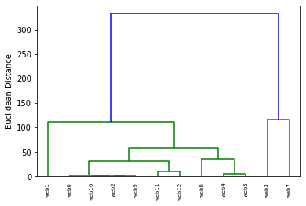

CONCLUSIONALL TASKS HAVE BEEN SUCCESFULLY IMPLEMENTED AND EXECUTED.